

Group: C1.010

López Cubiles, Antonio José - [antlopcub@alum.us.es](mailto:antlopcub@alum.us.es)

February 21th, 2024

PLANNING AND PROGRESS Report

**Repository: https://github.com/C1-010/Acme-SF-D02**

Contenido

1. Executive Summary 2

2. Revision Table 2

3. Introduction 2

4. Contents 3

4.1. Planing chapter……………………………………………………………………………………………………..3

4.1.1. Tasks………………………………….…………………………………………………………………..3

4.1.2. Screenshots………………………….………………………………………………………………..4

4.1.3. Budget…………………………………….…………………………………..…………………………5

4.2. Progress chapter……………………………………………………………………………….……..……………6

4.2.1. Progress records……………………………….………………………………………..………….6

4.2.2. Conflicts…………………………….…………………………………………..………………………6

4.2.3. Costs comparison…………………………….…………………………………………..………..6

5. Conclusions 7

6. Bibliography 7

# 1. Executive Summary

In this document I will showcase thew planning of the D01 deliverable, with all its tasks, estimated and real development times, estimated budgets and real costs and screenshots of the process.

# 2. Revision Table

|  |  |  |
| --- | --- | --- |
| Revision number | Date | Description |
| 1 | 21/02/2024 | Initial Version |
| 2 | 05/03/2024 | Advanced Vesion |
| 3 | 08/03/2024 | Final Revision with costs |

# 3. Introduction

This document is a report of the planning and progress of a specific deliverable. It encapsulates the meticulous planning process undertaken to fulfill the requirements of the deliverable and its progress.

In the planning chapter, I will provide a detailed listing of tasks completed to meet the deliverable's requirements, showcasing the task titles, descriptions, assigned personnel and roles, expected versus actual development time. Additionally, screenshots of the process are included, adhering strictly to the working methodology prescribed in lesson "S03 - Working together". Also, there is a budget estimation, showing the total estimated cost required for a task’s completion, estimated hours and personnel costs per role, as well as amortization costs.

In the progress chapter, a listing of progress records is presented, indicating the performance indicators defined in the project charter. This quantifies progress and also shows the quality of the work, distinguishing between good and bad performance. Furthermore, any conflicts encountered during the execution phase are described, along with the strategies employed to address them. Finally, a comparative analysis between the initially estimated costs and the actual costs incurred upon completing the deliverable is provided.

# 4. Contents

**4.1. Planning chapter**

**4.1.1. Tasks**

**Task 002**

**Description:** A training module consists of one or several short-term training activities aimed at extending or updating knowledge and skills related to the topic of a project. The system must store the following data about them: a code (pattern “[A-Z]{1,3}-[0-9]{3}”, not blank, unique), a creation moment (in the past), some details describing the training module (not blank, shorter than 101 characters), a difficulty level (“Basic”, “Intermediate”, or “Advanced”), an optional update moment (in the past, after the creation moment), an optional link with further information, and an estimated total time.

**Role/s:** Developer

**Planned time:** 50 min.

**Actual time:**  45 min.

**Task 003**

**Description:** Each training module is made up of training sessions. The system must store the following data about them: a code (pattern “TS-[A-Z]{1,3}-[0-9]{3}”, not blank, unique), a time period (at least one week ahead the training module creation moment, at least one week long), a location (not blank, shorter than 76 characters), an instructor (not blank, shorter than 76 characters), a mandatory contact email, and an optional link with further information.

**Role/s:** Developer

**Planned time:** 30 min.

**Actual time:**  43min.

**Task 004**

**Description:** The system must handle developer dashboards with the following data: total number of training modules with an update moment; total number of training sessions with a link; average, deviation, minimum, and maximum time of the training modules.

**Role/s:** Developer

**Planned time:** 30 min.

**Actual time:**  40min.

**Task 005**

**Description:** Produce assorted sample data to test your application informally. The data must include two developer accounts with credentials “developer1/developer1” and “developer2/developer2”.

**Role/s:** Developer

**Planned time:** 20 min.

**Actual time:** 1h 37 min. (97 min)

**Task 013**

**Description:** There is a new project-specific role called developer, which has the following profile data: degree (not blank, shorter than 76 characters), a specialisation (not blank, shorter than 101 characters), list of skills (not blank, shorter than 101 characters), an email, and an optional link with further information.

**Role/s:** Developer

**Planned time:** 30 min.

**Actual time:** 5 min.

**Task 014**

**Description:** Produce a UML domain model.

**Role/s:** Analyst

**Planned time:** 20 min.

**Actual time:**  23min.

**Task 015**

**Description:** Produce an analysis report.

**Role/s:** Analyst

**Planned time:** 30 min.

**Actual time:**  26 min.

**Task 016**

**Description:** Produce a planning and progress report.

**Role/s:** Analyst

**Planned time:** 10 min.

**Actual time:**  14 min.

**Task 001T**

**Description:** Review the documents written for this deliverable and look for mistakes.

**Role/s:** Analyst

**Planned time:** 15 min.

**Actual time:** 8 min.

**Task 002T**

**Description:** Test the functionality of the developed code and fix any last error.

**Role/s:** Tester

**Planned time:** 5 min.

**Actual time:** 3 min.

**4.1.2. Screenshots**

Initial definition of all tasks in the "to do" lane.

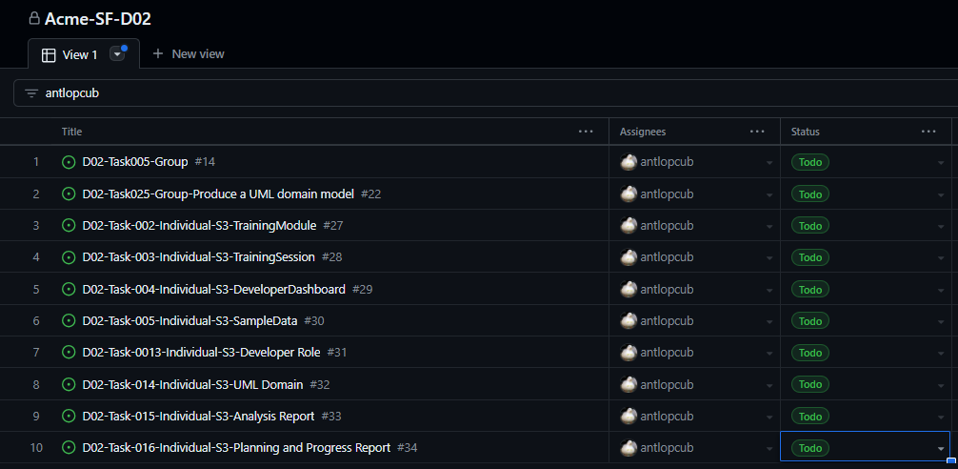

Screenshot in the middle of the delivery.

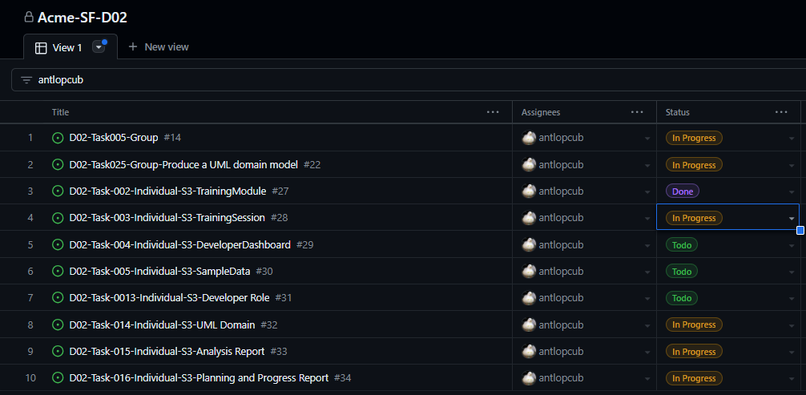

Screenshot in the end of the delivery showing all tasks in the "done" lane.

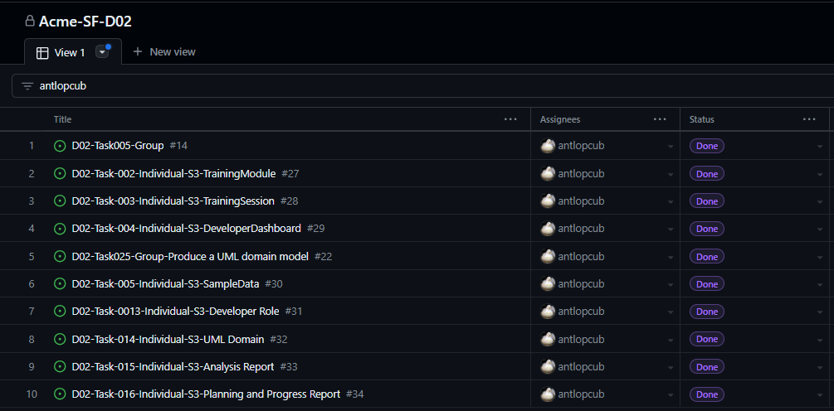

**4.1.3. Budget**

**Breakdown by tasks**

|  |  |  |  |  |  |  |
| --- | --- | --- | --- | --- | --- | --- |
| **Task** | **Role** | **Salary per minute** | **Estimated time (minutes)** | **Estimated Cost (€)** | **Real Time(minutes)** | **Real Cost (€)** |
| Task-002 | Developer | 0,33 | 50 | 16,5 | 45 | 14,85 |
| Task-003 | Developer | 0,33 | 30 | 9,9 | 43 | 14,19 |
| Task-004 | Developer | 0,33 | 30 | 9,9 | 40 | 13,2 |
| Task-005 | Developer | 0,33 | 20 | 6,6 | 97 | 32,01 |
| Task-013 | Analyst | 0,5 | 30 | 15 | 5 | 2,5 |
| Task-014 | Analyst | 0,5 | 20 | 10 | 23 | 11,5 |
| Task-015 | Analyst | 0,5 | 30 | 15 | 26 | 13 |
| Task-016 | Analyst | 0,5 | 10 | 5 | 14 | 7 |
| Task-001T | Tester | 0,33 | 15 | 4,95 | 8 | 2,64 |
| Task-002T | Tester | 0,33 | 5 | 1,65 | 3 | 0,99 |
| Reuniones | Developer | 0,33 | 240 | 79,2 | 220 | 72,6 |
| TOTAL |  |  | 480 | 173,7 | 524 | 184,48 |
|  |  |  |  |  |  |  |
|  |  |  |  |  |  |  |
|  |  |  |  |  | Amortización | 61,49333333 |

A straight-line amortization over 3 years has been considered. Also, the work hour costs for a manager or analyst role have been considered as €30, while for all other roles, it has been set at €20.

**4.2.** **Progress chapter**

**4.2.1 Progress records**

|  |  |  |
| --- | --- | --- |
| **Member** | **Performance** | **Action Taken** |
| Sevillano Barea, Alejandro | Punctuality and quality - Good | Does not apply |
| García Rivero, Andrés | Punctuality and quality - Good | Does not apply |
| Díaz Ordoñez, Pablo | Punctuality and quality - Good | Does not apply |
| Nieto Vicioso, Javier | Punctuality and quality - Good | Does not apply |

**4.2.2. Conflicts**

I have not encountered problems or conflicts during the development of this deliverable.

**4.2.3. Costs comparison**

**Estimated time:** 480 min (8 h 0 min)

**Actual time:** 524 min (8 h 44 min)

**Difference:** +44 min

**Estimated Cost:** 173.7€

**Actual Cost:** 184.48€

**Difference:** +10.78€

# 5. Conclusions

After seeing that the development time and the costs of this deliverable have been bigger than the predicted ones, and acknowledging that no big problems were found, we can affirm that the planning for this deliverable has been deficient, as the time needed for some tasks has overcome the estimated time, even when other tasks have been performed in less time, resulting into a bigger total cost.

# 6. Bibliography

"08 Annexes.docx" - Material provided in the DP2 subject at the University of Seville.Principio del formulario